

**SeekandHelp: Developing Mobile Application for a Localized Donation System**

**BY**

**NAN PEPIN**

**1001953764**

**Institute of Computer Science and Digital Innovation**

**B.Sc. (Hons.) Business Information Systems**

**UCSI UNIVERSITY**

**2022**

**Authorship Declaration**

Except where reference is made in the references, this report contains no material published elsewhere or extracted in whole or in part from a dissertation or report presented by me for another degree or diploma.

No other person’s work has been used without due acknowledgement in the content of the report.

|  |  |  |
| --- | --- | --- |
| Signature:  Nan Pepin |  | Date: 1/4/2022 |

**ACKNOWLEDGEMENT**

Thank you UCSI University for giving me the opportunity to successfully complete my Final Year Project entitle SeekandHelp Localized Donation System a period of two semesters, I am glad to express my utmost appreciation to those who has helped me throughout my Final Year. Special acknowledge to

**Associate Professor Dr. Abdul Samad Bin Shibghatullah**

Associate Professor in UCSI University

I would like to thanks to Dr. Abdul Samad as my supervisor for his never-ending efforts and supports while evaluating and supervising throughout completing the project. Besides, I would like to thanks to Assistant Professor Ts. Kasthuri A/P Subaramaniam as my second marker and lecturer of CC314 Project Design & Implementation subject for her guidance of the project. Finally, thank you to the participants who has involved in the online survey or user acceptance test towards finishing the project.

**ABSTRACT**

An online charitable donation has emerged as one of the most important applications today. Lack of transparency, unclear incentives, and possibility of fraud are all shortcomings in online charitable system. The purpose of this research was to develop Localization Donation App donating for charity. The evaluations and investigations of charity apps will be performed in order to compare and contrast existing charity applications' strengths and limitations. JomDonate, ShareTheMeal, SimplyGiving and GreatHeart are compared in terms of donation system. Google form platform is used to distribute the questionnaire and collect data from the respondents before it can gathered and analyzed. The application has been implemented using the Kodular builder Platform. In result, the adaptability of the app to the resolution and screen size of the device can be enhanced.

Contents

**CHAPTER 1** 1

**INTRODUCTION** 1

**1.1 Introduction** 1

1.2 Evolution of charity 1

1.3 The Internet and technology 2

**1.2 Significance of Project** 5

**1.3 Problem statement** 5

1. Transparency of donations 6

2. Unclear benefits 6

3. Potential of fraud 7

**1.4 Aims** 7

**1.5 Research Questions** 8

**1.6 Research Objectives** 8

**1.7 Hypothesis** 8

**CHAPTER 2** 10

**INFORMATION GATHERING** 10

**2.1 Systematic Review** 10

**2.2 Study and review on Existing Charity System** 11

2.2.1 JomDonate 12

2.2.3 ShareTheMeal 12

2.3.3 SimplyGiving 13

2.2.4 The Great Hearts Foundation 14

2.2.5 Comparison on existing systems 15

**2.4 Related work** 18

**2.5 Methodology** 19

**2.6 Questions in the survey** 20

**2.7 System methodology** 21

**CHAPTER 3** 23

**ANALYSIS** 23

**3.1 Application Analysis** 23

**3.2 Application Description** 23

**3.3** **Data Collection Analysis** 24

**3.4 Summarize of the result** 41

**3.5 Improvements** 41

**3.6 Functional Requirements** 42

**3.7 Non-Functional Requirements** 43

3.7.1 Performance Requirements 43

3.7.2 Hardware Requirements 44

3.7.3 Software requirements 44

**CHAPTER 4** 46

**SYNTHESIS** 46

**4.1 Architectural Design** 46

**4.2 Database** 47

**4.3 Process Design** 48

4.3.1 UML Use Case 48

4.3.2 UML Class Diagram 49

4.3.2 Activity Diagram 50

**4.4** **User Interface Design** 59

**CHAPTER 5** 68

**EVALUATION** 68

**5.1 Testing** 68

**5.2 User Acceptance Test** 68

**5.3 Discussion on the UAT Results** 78

**CHAPTER 6** 79

**CONCLUSIONS AND RECOMMENDATIONS** 79

6.1 Conclusion 79

6.2 Limits 79

6.3 Recommendations 80

References 81

# 

# **CHAPTER 1**

**INTRODUCTION**

**1.1 Introduction**

The advancement of information technology is fueling a new revolution, which would be manifesting itself in the transformation of human work systems from the traditional to the digital eras. Mobile phones, computers, and internet browsing are just a few of the most recent technological advancements that have made daily life easier for people. This highly productive and fast-paced information system has helped individuals from all sorts of backgrounds from generation to generation. Information technology, which combines computer and telecommunications technology, transforms the industrial paradigm into a post-industrial paradigm, as well as influencing people's behavior in their surroundings [1]. Consequently, changes in behavior take place in a variety of areas, including the philanthropy area.

As human beings, being socially frequently encountering obstacles in the process of their existence, resulting in human beings never being completely independent of the additional support of other humans. In turn, it stimulates the impulse to assist one another and assist one another since, at their core, human beings are willing to cooperate in order to achieve happiness in their life. Humans who live in communities are classified into groups based on the strata of society and rank. Using a system of classification that ranges from the amount of education to money, humans are divided into two groups, the wealthy and the less wealthy. However, the natural urge of human beings to help one another and to help one another has always led people who seem to be self-sufficient to be willing and able to help one another, one of which is through charitable contributions[1].

1.2 Evolution of charity

Contributions to charity are also linked to the development of the technological revolution, which has resulted in a modern society increasingly making donations in cyberspace, which are referred to as online charity. Compared to conventional charity, online charity is a modern call, in which the gift or transaction is always in the form of money and is made directly to the receiver using only a telephone or computer connected to the internet. Even during this Covid-19 pandemic, an online charitable donation has emerged as one of the most important applications today when it comes to quickly providing funds to those in need [2]. The use of online charitable platform is very beneficial to the community in that it allows them to channel information about donations and make it fast without having to meet in person. Usually in online donation, the donation given will be in the form of digital money. The advantages of online donation are it's more convenient to do and also has the option of making donations using an ATM transfer or a credit card. This makes it very easy for the community to donate and will save a lot of time to do other activities. In addition, with the availability of an easily available internet and technologies that connect everyone in delivering donation information faster. In addition, numerous digital platforms for donations are available, such as the charity's media website or social media, which can be accessed through a mobile phone or computer that is connected to the internet network.

1.3 The Internet and technology

The Internet is a medium for accessing a wide range of information and serving as a bridge between local and global communities [3]. The Internet is a collection of tens of thousands of computer networks that communicate information in accordance with a set of uniform rules or protocols that have been agreed upon by all parties. Because of this consistency, a computer connected to one of the Internet's networks can send text and images to another computer connected to another part of the Internet and have them shown on another computer connected to another part of the Internet [4]. Therefore, with the internet, makes it easier for local and global communities to be connected to each other and includes many parties such as companies, governments, organizations, and individuals or donors to send and receive data in the form of digital information. Even at this time of the pandemic, the need for the internet is seen to be growing.

The increasing use of the Internet and easy access has also made the Internet the main choice in the daily activities of Malaysians, including making donations. According to data reports released by from Department of Statistics Malaysia (DOSM), an individuals who use the internet climbed by 5.4 percentage points from 84.2 percent in 2019 to 89.6 percent in 2020. The percentage of people who use computers has climbed by 7.9 percentage points from 72.1 percent in 2019 to 80.0 percent in 2020. Meanwhile, the percentage of people who use a mobile phone climbed by 0.3 percentage points from 97.9 percent in 2019 to 98.2 percent in 2020, representing an increase of 0.3 percentage points [5]. The growth is due to the government's control initiatives to pull daily activities such as working, studying, and buying to be done digitally. Using the internet as a means of ethical funding is a viable option. Currently, all network access between two people is connected in a single network. This is because the Internet is the most effective way to connect all of its users without regard to distance or time [4]. Because of the wide usage and accessibility of the Internet, it has become the preferred method of conducting charitable activities. Thus, as a result, the necessity for the internet is considered quite high at this present moment.

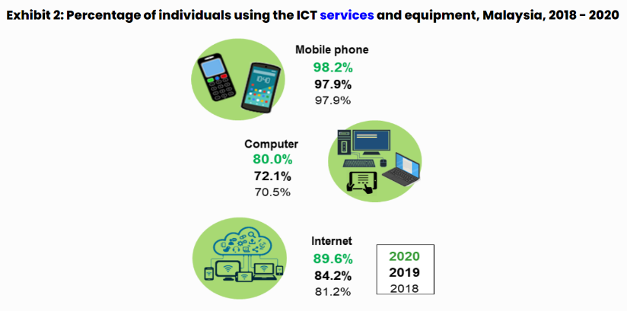

*[1]Figure 1. Source from Department of Stat*

The development of technology has made the internet undergo changes in terms of appearance and usability. From the beginning of the internet that only has a website for access, now there is the latest innovation where information on the internet can be accessed in the form of mobile applications contained in the gadget so that the information provided is more concise and complete. In addition, the advantage of mobile applications compared to websites is that mobile applications provide fast performance, user-friendly, attractive visual aspects, as well as a better user experience [6]. One of the devices used by many people is a smartphone. The use of smartphones today has become a trend so that users of conventional mobile phones are rarely found. The advantage of smartphones that attract its users is that smartphones have mobile applications that provide easy access to information for its users.

The existence of smartphones in the world has become a phenomenon that massively affects human activities with a very significant growth rate of smartphone users. Nowadays, smartphones, which are applications on mobile devices running operating systems (OS) such as Android, are among popular in Malaysia. According to data from Statcounter, the use of smartphones with Android operating systems reached as high as 75.1 percent in Malaysia, when compared to other operating systems used by other smartphones [7]. Android operating system being an open operating system, developers have the ability to create a wide range of applications for Android consumers. Android-based devices are typically packed with the most up-to-date technological features. Internet, GPS, Wi-Fi, camera, and motion sensor are some of the functions that are commonly found in Android devices. These qualities make obtaining numerous types of information relatively simple for the general audience. The GPS capability on Android handsets can be used to determine the public's position with relation to a specific site [8].

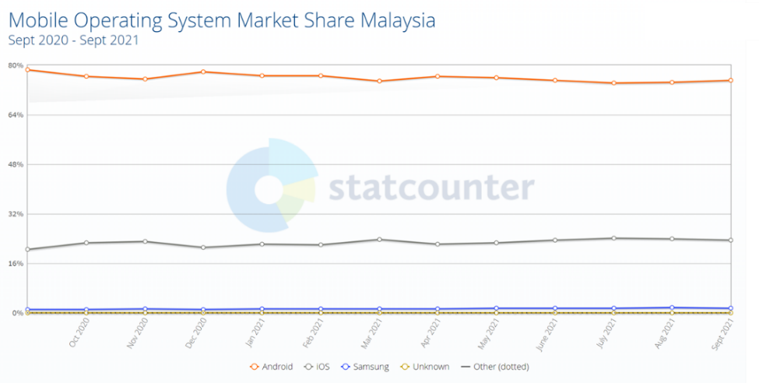

*Figure 1.1 Mobile Operating System Market*

Above all, by taking advantage of current technological developments, humanitarian activities and social concerns can be carried out more quickly and accurately. This is because the use of the internet which has become part of daily life makes accessing information easier. The Internet itself can be accessed in a variety of ways, one of which is through mobile applications. Phenomena and events that are happening in the surrounding environment or globally can be known as quickly as the pandemic that is hitting at this time. The society also has a role in the development of universal social and humanitarian concern activities. Therefore, Fundraising Activities have the potential to be done easily and quickly through the utilization of one of the current internet technology facilities.

## **1.2 Significance of Project**

The proposed project intends to provide incentives to all users who actively engage in charitable activities in Malaysia. It is expected that this system will be beneficial to all users in Malaysia, particularly those who wish to donate or help in the form of goods or services. Aside from that, it can also help individuals who needed help when they need it, especially when they are experiencing emergency. This makes it easier for them to locate and communicate with one another as they see helpful. The purpose of this research was to learn about the user experience when donating or seek for a charity. The evaluations and investigations of charity apps will be performed in order to compare and contrast existing charity applications' advantanges and limitations.

## **1.3 Problem statement**

Natural disasters, conflicts, health complications, and other personal issues that affect individuals or groups in society are all challenges that are sometimes unavoidable. When other people are in difficulty, we as human being want to always help them. As of today, we are in the midst of a pandemic crisis that has awakened many people to the realities of modern living. If in the past, getting to a location was uncomplicated and didn't require dealing through numerous procedure, it is no longer the case. In contrast to today's life, the movements are restricted, including the distribution of donations, due to the presence of movement regulation and social distancing issued by the government. In contrast to today's life, the movements are restricted, including in distribution of donations.

When the COVID-19 outbreak was found in Malaysia on January, 2020, following the number of positive cases increased, the government implemented movement restriction measures to combat the infection's transmission in the community. As a result, the country's social and economic sectors have been significantly affected. Many businesses were forced to close, and many people lost their jobs. To overcome this, many entities from the welfare sector, including the government, non-governmental organization (NGO), and individuals, have stepped up to help people who are affected and those in need. However, due to difficulties in restricting movement, many donations is delayed and disrupted, especially in remote locations [9]**.**

As a result of the restriction, the public's willingness to make gifts through digital channels has increased significantly over the past year. According to study [10][11][12]**,**  one of the factors of charitable giving in the context of online donations is merely the act of seeking monetary donations. There are many different sorts of online philanthropy platforms accessible, including websites, social media, and mobile applications for smartphones [13]**.** Although the use of digital technology allows for philanthropic activities to be carried out, there are still shortcomings in this online system. Previous research has shown that the lack of transparency, unclear incentives, and the possibility of fraud are all shortcomings in online charitable system [14][15][16]**.**

1. Transparency of donations

There are still some people who are afraid to donate due to a lack of information about the online charitable platform and a lack of transparency about how donations are allocated. Donors are also hesitant to donate online because they are unsure whether the party in need of the money is genuine or simply manipulating the donor's compassion. This is comprehensible just as people have come to expect to be able to follow their food orders from the kitchen to their doorsteps, many people also expect to be able to monitor their charitable donations from the point of donation to the end beneficiary.

1. Unclear benefits

The benefits of making a donation are unclear, whether from the fundraiser's or the donor's perspective. Fundraisers must use the fundraising platform to raise donations by publishing information about the campaign and the quantity amount of money they require. It will take quite a long time for a fundraising campaign to succeed before users can withdraw their funds, especially on crowdfunding platforms. This is because the amount of money raised is determined by the number of donors who are able to contribute to the campaign. This leads to confusion, and relying on a campaign for success is vague and ineffective for users who require immediate help. In addition, the dependence on monetary means that donors have no choice but to give donations in the form of money. Most current platforms only focus on money fundraising. This limitation causes the donor or receiver to be hindered because not all parties need help or to give contributions other than money. Some people need help such as daily necessities, time or manpower. Scholars used the disparities between time and money donations to illustrate that time donations require more human and social resources than money gifts [13][17]**.**

1. Potential of fraud

The ease of use of online donations and fundraising activities is also not free from the risk of misuse. There are many types of cybercrime can be happen one of which is fraud. This causes donors to be skeptical and cautious when making an online donations because they are suspicious of the information they are seeing, regardless of whether it is authentic or not.

As a consequence of these problems, there is a need for a new system that can improve the shortcomings of the current system in order to assist the community in carrying out charitable activities without hesitation and more efficiently in the present time. One solution that can be used in this solution are Localized Donation System. Localized Donation System is system that give user to share their donation based on their preferences and allow donation seeker to seek and advertise their need through the system. Thus, with the purpose system, it expected can be used to help and find donors or donation seeker to communicate directly.

## **1.4 Aims**

The main aim of this project is to develop a mobile application for a localized donation system which able to help the community to give or seek donations in the form of money or goods or other humanitarian help in the chosen location. In this application there will be information about donations shared by donors or donation seeker to the public. Donation seekers and donor can view the information and can make requests on the application for the donation. With the development of this application it will be able to improve the current existing system and can help the community to do donation activities more quickly and efficiently. This application has the concept of mutual aid where users will communicate directly with other users digitally without the need of a third party. The application will also be equipped with features such as location based services that can view the location information of users either donors or donation seekers near them. The application will also be designed in a user -friendly manner to make it easier for users to use.

## **1.5 Research Questions**

1. What are the advantages and limitation of existing charity application?
2. How can proposed localized donation system will helps to improve user’s experience?
3. How can proposed localized donation system improve user’s in charitable activity?
4. How to determine that all the features in proposed localized donation system are performing well?

## **1.6 Research Objectives**

The research objective of this project are:

1. To study and review of existing donation systems and compare it to discover the advantages and limitations. It helps the developer to have better understandings regarding the existing application.

2. To enhance the proposed localized donation system to improve user’s experience based on the limitations discovered. It helps to increase the user’s satisfaction for using the proposed application

3. To design and develop a localized donation system with all the requirement meet that are stated. It helps the proposed application to meet the user’s expectation.

4. To evaluate and test the proposed localized donation system with other users to make sure that all the features are working well. It helps to determine all the bugs and defects that can be improved in the proposed application.

## **1.7 Hypothesis**

The hypotheses of this project are:

1. There are a number of benefits and drawbacks to using the current charity application. To develop ideas about how to make improvements to the proposed donation App, it is critical that the existing charity App's benefits and drawbacks are identified. A systematic review was undertaken in order to evaluate all of the existing charity applications. In order to determine all of the advantages and limitations of existing charitable applications, comparisons between them are performed. The advantages discovered will be used to enhance the proposed charity application, while the drawbacks identified will be addressed in the proposed Application.

2. The proposed charity app contributes to an improved user experience.

Based on the constraints and viewpoints gathered from the systematic review and data collecting, the proposed charity application will be developed. The proposed application's performance will be enhanced as a result of the improvements. As a result, it contributes to the enhancement of the user experience when the proposed application is being used. Having a positive experience with the proposed application will increase the likelihood that users will be satisfied with the apps. In turn, this will lead to a rise in the number of users who express an interest in using the proposed application.

3. By including all of the mentioned feature improvements, the proposed charity app will meet user expectations.

After conducting a systematic review and collecting data from online survey participants, application design ideas will be developed. All functional and non-functional specifications for the proposed application will be identified in order to provide the developer with clear directions for development. The charity app will be designed and developed with all functional and non-functional requirements defined in order to suit the user requirements who will be using the application.

4. The performance of all functionalities in the suggested charity App can be evaluated through user testing.

In order to ensure that the proposed application performs as expected, a User Acceptance Test (UAT) will be carried out. This helps to guarantee that the proposed new application is approved by a larger number of people overall. Furthermore, all bugs or defects can be identified during UAT testing, allowing developer to be corrected first before proposed application is delivered to the next client.

# **CHAPTER 2**

## **INFORMATION GATHERING**

## **2.1 Systematic Review**

Donating in contemporary terminology is better known by the term philanthropy [18]. In addition to philanthropic terminology, there are also those who use the term charity is also often used for social fundraising activities. In short, a donation is a gift that is given voluntarily or sincerely without the expectation of receiving something in return from the person who made the gift. It is possible for donations to take the form of money or other tangible goods such as food, clothing, toys, or time, but this is not always the case, particularly in the event of a disaster emergency or under certain other circumstances such as donations to provide humanitarian aid or developmental aid [1]. Even in the middle of the presence of Novel Coronavirus (Covid-19) pandemic [19], many people all across the world, including those in Malaysia who are kind-hearted, have donated various forms of donations to those in need [19].

As pandemics nor natural disaster hit the world, plenty of websites and mobile applications have sprung up that act as organizers, bringing individuals who want to help such campaign organizers and funders together along with people who are in need of help. Today, the emergence of charity platforms makes it easier for anyone who wants to donate or raise funds. Only with the internet, online charity websites can be accessed. As with the funding platform bridges between fundraisers and donors. These sites are also connected with e-banking, credit cards and various platform so that users can more easily donate. As quoted in the book The History and Future of Technology by Robert Ayres, defines a system is a group of two or more interrelated components or the unification of system to achieve a common goal. It can be concluded if the system is a set of elements that are interrelated and influence each other in doing joint activities to achieve a goal [20]. Therefore, the donations made will be agreed by both interested parties until it reaches the receiver of the donation.

Differences than modern charity, traditionally charity conducts fundraising with various techniques such as face to face interaction between two or more people. Face to face meetings is done between the fundraiser and prospective donors to hold a dialogue with the purpose of offering mutually beneficial cooperation programs. This face to face activity can be done with a personal visit to someone's home, in an office, a company, with the same purpose, or make a presentation in a special meeting. In addition, a special event is also a traditional way which is the practice of fundraising by holding special fundraising events or utilizing certain events attended by many people to raise funds [17].

Study by CAF's The World Giving Index, there has been an increased awareness of the need to help others. For the record, according to the CAF's The World Giving Index 2021 study, Malaysia ranks 29th out of 114 nations in terms of charitable giving [21]. Various factors such as age, education, religion, and income are used to determine the attitude of the Malaysian community toward charitable giving. The main reason for the Malaysian community to donate is the desire to help those in need [22] [23]. Furthermore, the great degree of charity demonstrated by the Malaysian people over the last few years has emerged at a time when the country has been hit by financial distress and natural disasters such as the current pandemic situation now [24]. Many institutions, including government agencies, non-governmental groups, and even individuals, have stepped out to offer help. Regardless of their background, they have demonstrated charity through donations. The advantage of doing the practice of giving donations provides benefits and something of value to those who need it and it not only benefits the individual but also to the community and the country. Giving donations can drive a person to be self-sufficient in order to improve living conditions. It can also help in the solving of economic and social problems as well as the needs of the community's family [1].

## **2.2 Study and review on Existing Charity System**

Reviews of existing system are vital for understanding the functionality of the system as well as how effectively the design is developed. It is an essential aspect of coming up with a new idea and avoiding the application's faults in the process. In this study, observations are made in determining the comparison in the existing system in order to be able to identify deficiencies to the system for improvements to the donation system in the future. In this observation, the four systems that are existing is compared namely JomDonate, ShareTheMeal, SimplyGiving and GreatHeart.

### 2.2.1 JomDonate

One of the existing system currently in use is JomDonate. JomDonate is a website platform that focuses on fundraising for people in need. JomDonate was built in 2015. Observations on the JomDonate website found that the website has registers and logins for users of their system. Apart from that, this system also has several target categories of the campaign, among others, such as natural disasters, education, marriage, and others. The JomDonate website also provides features such as users can share on social media and info on the campaign and the amount of their fundraising. The process of making a donation on this platform is accepted only in the form of digital money rather than online banking and credit or debit cards through their website. According to the collection amount on the JomDonate platform, to date, a total of RM 2,278,974 total funds have been obtained and has had a total of 80,812 donors with the total number of campaigns currently accumulated is 202 campaigns. However, the limitations of JomDonate is that its system can only be accessed through the website. Apart from that, JomDonate only focuses on fundraising and only accepts donations in digital money. In addition, the user interface on the system is less attractive, especially for blog users. Move over, from observation and testing of some of social media sharing features through Whatsapp system is not properly working [25].

|  |
| --- |
|  |

Figure 2.1 JomDonate website

### 2.2.3 ShareTheMeal

ShareTheMeal is developed by the World Food Program (WFP) under the auspices of the United Nations (UN). The purpose of this application is to address the problems in place of the refugee crisis in Europe and the Middle East, especially children. The Share the Meal app is available globally on their website, iOS and Android. Until now, it was found that a total of 124,517,883 meals have been collected. The ShareTheMeal system shows a simple design that contains about home, about us, faqs and makes donations. The process of donation is that the donator will choose the type of meal to be donated, once, weekly or monthly virtually. This system provides a user to use payment of their PayPal or credit card. In addition, this system provides a feature where it will display the location where the donation is channeled after the donation is made. The drawback of this system is that it only focuses on fundraising of meals and the systems do not provide additional features such as filtering categories, media upload features, and no social media sharing [26].

|  |
| --- |
|  |

Figure 2.2 ShareTheMeal website and application

### 2.3.3 SimplyGiving

Simplygiving is an organization that focuses on providing facilities for community members either individuals or groups to raise funds. Like JomDonate, funds are made through campaigns or campaigns conducted through its main website. Fundraising is a public fundraiser, where the funds are donated by donors to people or institutions in need. Unlike JomDonate and SharetTheMeal, this system does not display the amount of fundraising but instead displays the campaigns that have successfully raised funds on the system play.

Furthermore, according to research on this system, it can be seen that this system shows features such as the main menu such as search features, donate and fundraise now. This system also provides sharing features on social media such as Facebook, WhatsApp, Twitter, WeChat and linkeld. The process of donation in this system is the donator will choose the amount to be donated from RM75 to RM1500. The system provides payment via credit card, online banking and PayPal. Weaknesses in this system, the system can only be accessed through the website. In addition, the system does not provide features such as category filtering and the user interface of the system looks a bit old. Additionally, there is no option in the amount of making a donation and charges a fee of 5 per cent each time a donation is made by a donor [27].

|  |
| --- |
|  |

Figure 2.3 SimplyGiving website

### 2.2.4 The Great Hearts Foundation

Great Heart Charity is a charitable organization focusing on charitable work in channeling goods, services or even finances to those in need. Observation on the system on the main page display is seen to have several menus such home, about us, our programs, apply aid, hall of fame, support us, donor relations and contact us. The system provides various payment methods for donors who want to donate such as online banking, PayPal and credit card, shoppe pay, boost, grab pay and touch and go. In contrast to the three systems above, the way Great Charity receives funds uses both methods, either conventionally or online. Conversely, they accept donors who go directly to their location to donate or to be their volunteers. While online, they accept donations by online payment through the website. Similar to ShareTheMeal, donors can choose the type of donation payment either on a one-off, weekly, monthly basis. In addition, Great Heart provides charities such as registration being voluntary. The drawback of this system, this system can only be accessed through the website. In addition, same as JomDonate, ShareTheMeal, SimplyGiving this system only focuses on fundraising and only accepts donations. In contrast to the three systems discussed GreatHeart accepts both funds either in the form of digital money or physical goods. Additionally, the system does not provide filtering features and the appearance of the website design is a bit outdated [28].

|  |
| --- |
|  |

Figure:2.4 Great Heart Charity website

* + 1. Comparison on existing systems

Table 1: Comparison on existing systems

|  |  |  |  |  |
| --- | --- | --- | --- | --- |
| Criteria | JomDonate | ShareTheMeal | SimplyGivng | GreatHeart |
| **Platform** |  |  |  |  |
| Web Platform | **√** | **√** | **√** | **√** |
| Mobile Application |  | **√** |  |  |
| **Services** |  |  |  |  |
| Money donation | **√** | **√** | **√** | **√** |
| Goods donation |  |  |  | **√** |
| **Features** |  |  |  |  |
| Search | **√** | **√** | **√** |  |
| Campaign | **√** | **√** | **√** |  |
| Filters | **√** |  | **√** |  |
| User profile | **√** | **√** | **√** |  |
| User blog | **√** |  | **√** |  |
| Social media sharing |  |  | **√** | **√** |
| Media uploaded | **√** |  | **√** |  |
| User friendly interface |  | **√** |  |  |
| Location based service |  | **√** |  |  |
| Feedback | **√** | **√** | **√** | **√** |
| Push notification |  | **√** |  |  |
| Bilingual | **√** | **√** | **√** | **√** |

Based on the table of system comparison above, which divided into three criteria, namely the platform run on the existing system, the services provided and the features that exist in the current system. Of the three, it was result that the shortcomings which is the mobile application platform, goods donation types, user-friendly interface, location based services (LBS) and push notifications are the shortcomings in the four systems above.

### 

Mobile application

Based on the table comparison above, only the ShareTheMeal system is provided on both platforms, either websites or mobile applications, compared to the three systems JomDonate, SimplyGiving and TheGreatHeat that can only be accessed through their website platforms. In other words, considering the limitations of apps of this type that may be used, as well as the chances to create mobile applications for donation on smartphones. Furthermore, currently, everyone has a smartphone, and the technological community has come up with a lot of fresh ideas for smartphone applications [29]. As a result, in comparison to a computer or laptop, this idea can be considered for developing new systems on mobile applications

User-friendly interface

Comparison of the user interface of the four systems seen ShareTheMeal has a consistent and user-friendly design. This is because the observation in using the application and website of this system are very easy to understand when compared to JomDonate, SimplyGiving, and Great Heart, in which the system design is out-of-date and has a confusing layout and menu arrangement for users, especially those who are unfamiliar with what they have to offer. Because UI design is a complicated process, it must be built with a minimalistic design because a user interface that is suitable for visitors is a critical factor to consider in the creation of applications [30] [31]. Therefore, the lack of a user interface will improve the system that will be implemented in purpose system.

Goods donation

Subsequent comparisons and findings on system services found that Great Charity accepts donations in the form of money, goods or services compared to the other systems that only accept money digitally. The goods donation can be in the form of daily items, used items, or even volunteering is a feature that allows donors to choose. Despite the number of donations received, there are signs that donors are dissatisfied with charitable organizations' performance, and the majority of them would like to know more about what happens with their donations, necessitating the development of internal and external efficiency and effectiveness measures. As a result, it’s vital to note that charity organization qualities were found to be major predictors of monetary donations [32]. In the delivery of such information, a good performance is crucial for a charity system that allow users flexibility to choose whether to donate their money or the goods. This feature really helps donors who lack resources or do not have access to a resource in doing charity. In addition, improvements and additions to this feature add trust and transparency to donors to make donations on the basis of their own personalities [13].

Location based service

Comparison of Location-based services features resulted in only the ShareTheMeal system that provides this feature compared to the other systems above. This indicates the lack of this feature will be implemented into the new system to be built. LBS (Location-Based Service) is a form of service and is based on the user's current position. Sometimes the user does not know where the located is. Therefore the system will work to help the user find his current donation position. Furthermore, once the position is known, the data can be used to meet the needs of the user and allow the user to access all information related to his current position via GPS [33]. The usefulness of this feature is of interest to the current system as in doing charity, with this location-based service the donor or receiver will be able to know the location of the donation in a place. This makes it easier for them to find the location information and saves time.

In summarize, the result of the comparison between the four charity-based systems above will be used to build a new system which is for the purpose project. With the goal of enhancing the feature that compared, so that the new system will be more improvements and more user-friendly. Thus, user loyalty and transparency can be achieved. The first improvement is the system will be built on the mobile platform. The second is an improvement on the user interface of the system that will be built. The third is that adding feature services for goods donation thus donator can sharing of their donation. And fourth is adding the Location-based services (LBS) feature to the new system. This feature will allow users to share, seek the location will be donated information in a place.

## 

## **2.4 Related work**

Study by [34] proposed “Mobile application: donate day”. The application, which based on the Android operating system, allows users to donate their items to Malaysian charities. Databases and an event page are among the application's functionality features. The author conducted quantitative research and used observational methods on different online charity sites in this study. This application was created using the android studio application development tool and a java programming language that is compatible with Android. The visual modelling tool of the system is created using Unfiled Modeling Language, which consists of diagrams such as use case diagrams and sequence diagrams, while the prototype technique is used to develop the system interface [34].

[35] Proposed of “UNNATI SAMAJ”. The proposed system is an Android web-based application with a charitable concept that allows users to donate commodities such as food, clothing, and other necessities to the nearest non-profit organizations. Authors employ a literature study to examine previous research systems in data collection as part of their strategy. The app is built with flutter technologies and includes features like notifications and chat boxes that connect donations with neighboring non-profits. The author developed a Use Case Diagram to explain the actions of donors and NGOs on the proposed system when creating the system design.

Study by [36] proposed evelop "Dug-Uhay : A Blood Donor Finder Application" is the name of the system. The authors of this study created an application that focuses on finding blood donors. This web-based application was created to assist the community in obtaining blood from nearby donors through the use of location-based service technology. In order to acquire meaningful data, researchers employ a combination of quantitative and qualitative methodologies in their planning. In the development of this system, researchers use spiral models and tools like as the Microsoft Visual Studio environment, as well as the #C language [36].

The results of three articles selected from the Google Scholar database are shown in the associated with the literature study. In terms the concept of philanthropy is applied in all three articles, [36] which is focusing to blood donation app. While [34] [35] focusing to the donation of goods and humanitarian relief. Both [35] [36] has proposed web-based applications as their platform and [36] which involves use of location-based services technology for the application, while [34] paper proposed based on Android apps. Despite three projects having different system, but all of the reviewed systems have the same purpose which is donation and it will be a reference to the system that will be developed SeekandHelp mobile Application.

## **2.5 Methodology**

2.5.1 Research Method

For the data collection, the survey will be out in the form of an online questionnaire as it has a low return rate and individuals will be more willing to respond to questionnaires [37]. Types of survey questions that will be utilized in this questionnaire are single response questions, multiple-choice questions, Likert scale questions, and open-ended survey questions. A single answer question is a survey question that employs the radio button format of the circular button that represents the choices in the list to allow respondents to select only one answer from a list of options. Multiple-choice questions, as contrast to single-answer questions, are typically signified with a rectangular checkbox. Respondents were given the opportunity to check all of the alternatives answer that were presented. Likert scale questions are surveys that are used to measure the thoughts and feelings of respondents and consist of a variety of alternatives ranging from strongly disagree to strongly agree. Respondents' opinions or attitudes concerning the topics under discussion were measured using a Likert scale. Additionally, the other type’s survey question will be use in this survey question is an open-ended survey questions. This types of survey question will require respondents to input their responses into a comment field.

Google form platform is a tool that will be used to distribute questionnaires to respondents. Google form is the tool of choice in disseminating this survey because it is online and can reach users in urban or rural areas. For this study, the survey will be distributed to adults who are live in urban or suburban locations. The distribution of this questionnaire is done randomly on online platforms such as CN, social media, WhatsApp, Facebook and others. This survey of questionnaire aims to collect at least 100 participants of their responses.

## **2.6 Questions in the survey**

Section 1 is a questionnaire about the demographics of the respondents. In this section, there are 4 questions will be ask which are gender, age group, level of education and employment status. Demographic questions are an important aspect of conducting a survey. Demographic questions are designed to help locate and determine factors that may influence respondents.

Section 2 of the questionnaire will be asked about the respondent's behavior in charity activities. In this section, there are 11 questions that will be asked to participants which are about whether they are donators or receivers of donations. The questions asked are related to the frequency of their charity activities, how, where, what items are donated or they want to request, what are the challenges they have faced and so on.

Section 3 of the questionnaire will ask about participatory experiences in using the charity mobile app. In this section, 5 questions will be asked about whether participants have ever used the charity application on their smartphone and their opinion of their experience in using the application. In this section, two questions are in the form of short answer questions and three questions in the form of Scala like answers.

## **2.7 System methodology**

Selecting methodology is important to carry out for the system development. Choosing the right method also plays an important role so that the project runs smoothly. According to the study [38] Waterfall, Iteration, V Model, Prototype and Spiral model has been compared. The analysis shown each model has its own advantages and disadvantages. For developing small project, Waterfall model will be the suitable approach to be used. According to this methodology, the steps are as follows: requirements gathering, system design and development, implementation and testing, deployment, and maintenance. The drawbacks of this model is once a phase of development was completed, development moved on to the next phase in the sequence, with no way to go back to the prior phase. Thus, new modified waterfall is proposed. According to [39] the Modified Waterfall Model is similar to the waterfall model in form and function. The modified waterfall was used in providing function and overlap between phases, where it is a repetitive model. Additionally, the modified waterfall is used to provide function and overlap between phases, as it is a repeated model. As a result, the development processes are accessible in order to facilitate flexibility and fulfillment of features, objectives, and tasks, as well as document efficiency and quality control, through the maintenance and implementation of the programme at any moment and stage.

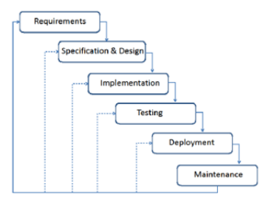

Figure 2.5 modified waterfall approach [39]

The modified waterfall approach was used to work on this final project in the Software Development Life Cycle (SDLC) stage, which included analysis, design, coding, testing, and deployment. The stages completed in the preparation of this final product are only up to the testing stage. The modified waterfall method was chosen since it is adaptable and versatile in terms of project development. Follow-up activities are carried out in this model to develop this project. This modified waterfall model, which differs from the standard method in that it can be reversed and confirmed if modifications need to be made, can return to the prior phase. This model was chosen because the phases are parallel, with the output of the first phase flowing linearly into the second phase, and so on. It's also simple to track the progress of this modified waterfall model.

1. Analysis: Conducting questionnaires and about the system that is devoted to donation activities. The community was asked about the system and donations in the survey and interviews. Fill out the survey regarding having trouble using the donation system and making donations. The questionnaire's contents inquire about what things are donated and how they are donated.
2. Design: The system is designed using the customized waterfall approach, based on questionnaire survey carried out by respondents about the system and donations.
3. Coding: Using the block programming language and backend to create each functional module
4. Testing: UAT is used to test the connectivity of each functional module that was created using the Kodular builder platform

.

# **CHAPTER 3**

## **ANALYSIS**

## **3.1 Application Analysis**

Kodular Application Builder is used to create the proposed seekandhelp Application for this project. The Android emulator and Windows 10 are the other software tools and operating systems that have been employed in this project. Block programming is used to create Android applications, and Kodular is an online service that gives support to improve developers in the development of these applications. To put it another way, Android applications are created without the requirement for developers to manually enter in programme code. This Kodular offers a number of advantages, including the Kodular Store and the Kodular Extension IDE, which make it easier for developers to publish Android applications to the Kodular Store and to create blocks of IDE extension activities according the user's requirements. Kodular app development requires the use of an Android emulator in order to run and test the app. Aside from that, the Firebase Database API and the Google Map API, which are both used in this suggested application, are supported by Kodular. Firebase Database API allows users to create, store, and delete information regarding their preferences that they want to share, whereas Google Map API allows users to view a Google Map of the location they are now in.

## **3.2 Application Description**

Applications will be developed on the basis of systematic reviews and data collecting that have already been carried out in the topic. The proposed software will be more refined and user-friendly as a result of the goal of improving the aspects that have been compared in the first place.   The first enhancement will be that the application will be based on a mobile platform instead of a desktop one. The second is an enhancement to the user interface of the system that will be developed. The third step is to include feature for category goods to donation which, allowing donors to share their donations with other users. The fourth step is to include LBS functionality into the new system. Users will be able to share information and find the location of donors or receivers of donations through the use of this function.

* 1. **Data Collection Analysis**

After the survey form has been completed and the replies from the 110 respondents have been collected, the data will be analyzed based on the responses received from the respondents.

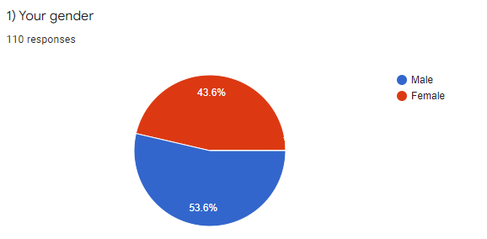

*Figure 3.1*

Figure 3.1 illustrates a pie chart indicating the number of respondents based on the gender of those who responded to the survey questions. The result shown male respondents represented 53.6 per cent of all respondents. Moreover, a total of 43.6 percent of the respondents indicated that they were female, As a result, on average, out of 110 respondents gathered, 61 were male, 48 were female has participate in this survey.

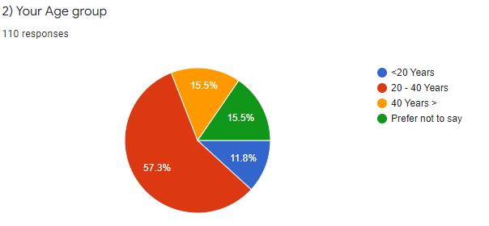

*Figure 3.2*

Figure 3.2 illustrates the overall age group of those who answered the survey questions. The results of pie chart show that a total of 57.3 percent, or a total of 63 respondents, are between the ages of 20 and 40 years. Thereafter, the next 15.5 per cent, or a total of 17 responders, comes from the group of people between the ages of 40 and above, as well as from the group of people who prefer not to share their age. While 11.8 percent, or a total of 13 respondents, are under the age of 20, the majority of respondents are beyond the age of 20.

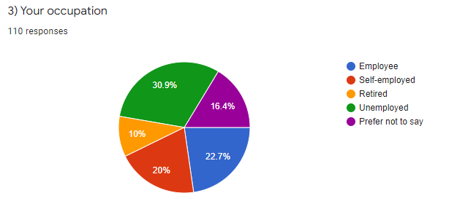

*Figure 3.3*

Result of respondents are visualized in Fig 3.3. There are 34 respondents who are unemployed, as indicated by the percentage of 30.9. The number of employed respondents is 22.7 percent, representing a total of 25 respondents, while the number of self-employed respondents is 20 percent, representing 22 respondents, and the number of respondents who choose not to prefer their occupation is 16.4 percent, representing a total of 18 respondents while the number of retired respondents is 10 percent, representing 11 respondents.

Based on the data gathered, it can be concluded that the vast majority of those who took part in the survey are unemployed. The survey that was done focusing on charitable in general, and the participants in this study came from a variety of different employment backgrounds as well. As a result, measures about employment are generally asked to determine the level of balance or unemployment among those who take part in this survey.

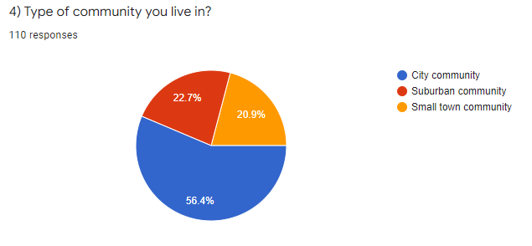

*Figure 3.4*

The results of the survey on the type of community in which respondents live are visualized in Fig 3.4. The pie chart illustrates that the biggest percentage, 56.4%, comes from a total of 62 respondents who indicated they live in urban communities. The next highest percentage, 22.7 percent, represents a total of 25 respondents who live in suburban communities, while the lowest percentage, 20.9 percent, represents a total of 23 respondents who reside in small-town communities. In short, respondents from urban areas are more likely to take part in this survey than those from sub-urban and small-town areas.

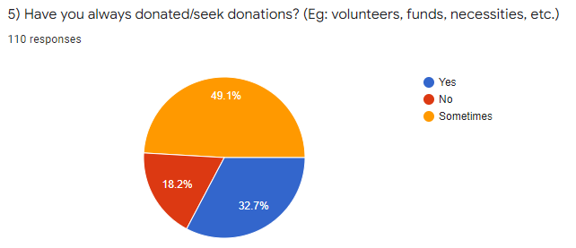

*Figure 3.5*

Figure 3.5 presents the total number of 110 respondents who have donated or who are looking for donations. The results of the pie chart illustrate that the highest number of respondents which is 49.1 per cent, or 54 of the total respondents stated that they sometimes do or seek donations. Followed by 32.7 per cent representing a total of 36 respondents who always donate or seek donations, and a further 18.2 per cent representing a total of 20 respondents who have never donated or requested donations. According to the results of this survey, the average number of respondents who make or seek donations is higher than the average number of respondents who have never made or sought donations. This indicates that charitable giving and seeking donations are activities that also respondents generally participate in it.

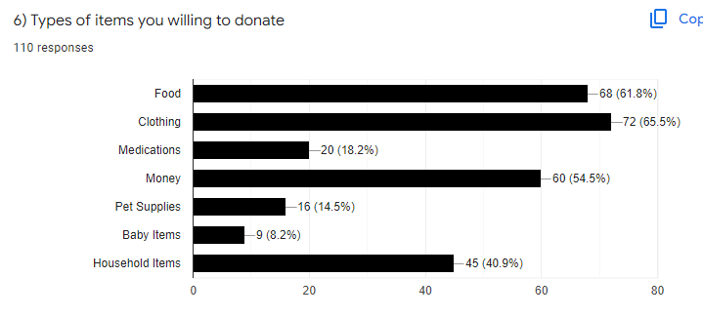

*Figure 3.6*

Figure 3.6 illustrates a bar chart indicating the number of different types of items that respondents are willing to donate in relation to the total number of items. The bar chart shows that clothing is the most common type of item to be donated by respondents, amounting to 65.5 per cent of all items donated or 72 respondents in total.

Followed by 68.1 per cent of respondents who indicated a willingness to donate food items, totaling 68 respondents. The third category includes up to 54 per cent of 60 total respondents who are willing to offer items in the form of money. The fourth item that people are willing to donate is a household item, which scored 40.9 per cent of the survey, reflecting a total of 45 respondents. Medication ranked fifth, with 18.2 per cent of the total of 20 respondents. Followed by pet supplies at 14.5 per cent, representing a total of 16 respondents, and baby items at 8.2 per cent, indicating a total of 9 respondents willing to donate their items.

According to the data collected, the most common types of commodities given to persons in need were clothing, food, and money. This also indicates that respondents were involved in giving charity in accordance with the types of items they were able to provide.

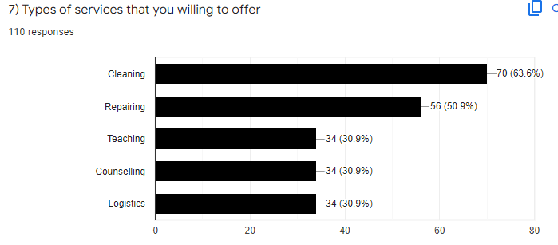

*Figure 3.7*

Figure 3.7 illustrates the results of the survey regarding the types of services that respondents would like to provide to those in need. The bar chart depicts a total of 63.6 per cent, or a total of 70 respondents, who are willing to provide cleaning services. Following that, service repair at 50.9 per cent represented a total of 56 respondents, and teaching, counselling, and logistics at 30.9 percent each represented a total of 34 respondents.

According to the data collected, the type of services offered by respondents in the form of cleaning and repairing is the most common of the services which are provided. This also implies that respondents offer services in accordance with the types of services they are capable of performing.

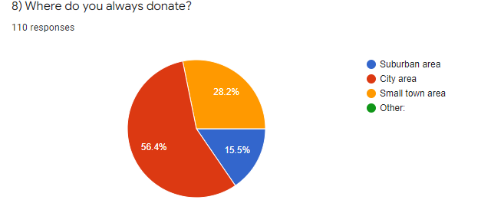

*Figure 3.8*

The results of Figure 3.8 are based on a survey that shows the respondents donated location. The pie chart illustrates a result of 56.4 per cent, which indicates a total of 62 respondents who made charitable contributions in the city. Following that, 28.2 per cent of the 31 responses were by respondents who donated in small-town areas, while 15.5 per cent, or 17 responses, were by respondents who donated in suburban areas.

In summary, out of 110 respondents, respondents who donated in the city area were the most frequent when compared to respondents who donated in the city area and suburban area. This indicates that the majority of respondents to this survey donated in accordance with their preferred donation location.

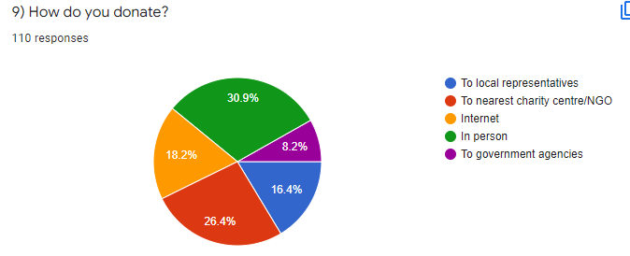

**Figure 3.9**

The results of a survey in which participants were asked about their charitable donations practices are visualized in Fig 3.9. The pie chart illustrates an overall percentage of 30.9 per cent, which represents a total of 34 respondents who give in person to make their donation. Representing 26.4 per cent a total of 27 respondents made a donation to a local charity centre and also non-governmental organization (NGO). It was discovered that 20 respondents which made donations through the internet, accounted for 18.2 per cent of the result. Those respondents who reported that they made donations to their local representatives or government agencies accounted for 16.4 per cent of the total, and those who stated that they made donations to their local representatives or government agencies made up 8.2 per cent.

In summarized, according to the data collected from this survey, the most common approaches of donating are in-person, through a local charity center, and also through the internet. The findings of this study indicate how respondents preferred approach when making a donation

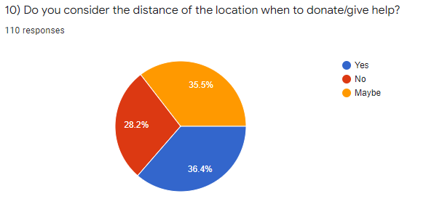

*Figure 3.10*

Figure 3.10 shows the results of a survey of respondents regarding the distance and location of their donations. On the pie chart, the data result of 36.6 per cent, or a total of 40 respondents, is from respondents who agreed to take into consideration the distance and location of donors while making charity donations. While a total of 35.5 per cent, or a total of 37 respondents, indicated that it is likely to take into account the distance and location when making a donation. Account at 28.2 per cent which represents a total of 30 respondents, indicated that they do not consider distance or location when making a donation.

In summary, out of the 110 data points obtained, the majority of respondents stated that their distance and location should be taken into consideration. This survey is to evaluate respondents according to their willingness to make donations regardless of the distance and location.

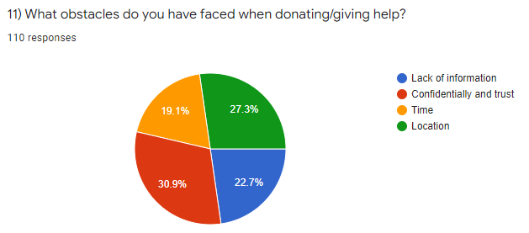

*Figure 3.11*

Figure 3.11, results from show of what respondents' encounters with donation obstacles were presented. According from the pie chart, a total of 30.9 per cent, or a total of 34 respondents, answered that the most challenging part of donating is preserving confidentiality and trust in the charity. A total of 30 respondents stated that location was a challenge when making a donation which resulted in 27.3 per cent of the total number of respondents. Further, 22.7 per cent, or a total of 24 respondents, stated that a lack of information is their major challenge while 19.1 per cent, or a total of 21 respondents, stated that a lack of time is their main obstacle in making donations. To conclude, based on 110 responses, the most common challenges faced by respondents, are a lack of confidence and trust, a lack of location, and a lack of information. Apart from determining what motivates respondents to donate, it is necessary to consider the obstacles they may experience.

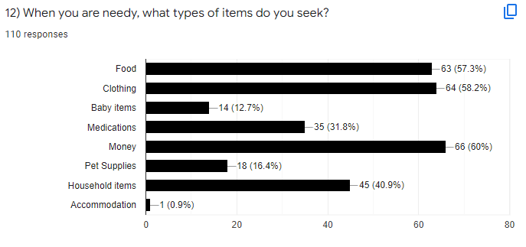

*Figure 3.12*

Figure 3.12 shows the results of a survey conducted with the respondent regarding the respondent's needy. According to the results of the bar chart, 60 per cent of respondents, or 66 in total, indicated that money is a necessity that they seek when in need. Clothing is the most sought-after item, according to a total of 58.2 per cent of respondents representing a total of 66 respondents, followed by food, which received 57.3 per cent of responses representing a total of 63 respondents. Furthermore, 40.9 per cent indicated the need for household items, representing a total of 45 respondents, while 31.8 per cent said they need medicine items, representing a total of 35 respondents. While pet supplies accounted for 16.4 per cent of 18 respondents and baby supplies accounted for 12.7 per cent of 14 respondents.

When it comes to searching for types of items when are in need, according to the data collected, respondents most frequently look for money, clothes, and food. This suggests that the respondents to this survey sought help based on the type of their preferred item that met their needs.

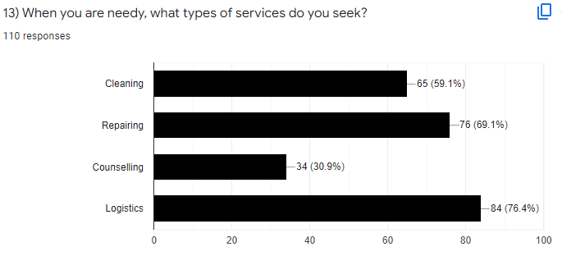

*Figure 3.13*

Figure 3.13 shows the results of a survey conducted among respondents to identify the services that they would require if they were in need. According to the bar chart, 76.4 per cent of the respondents, or a total of 86 respondents, indicated that they were looking for logistical services. Total of 69.1 per cent, which represented 76 respondents are seeking repair services. Furthermore, cleaning and counselling services were sought after, with 59.1 per cent and 30.9 per cent, respectively, representing a total of 65 and 34 respondents.

According to the data collected in summary, the types of services such as logistics, repair, and cleaning are the most frequently sought by respondents when they are in need. This implies that the respondents who took part in this survey looking for service support based on the type of preferred services that met their needs when they were in need.

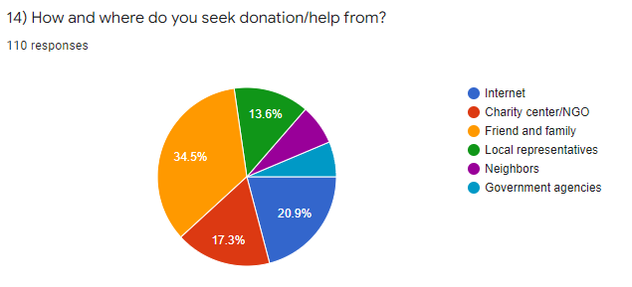

*Figure 3.14*

Figure 3.14 show respondents were asked where they looked for donations when they were in need. It was discovered that 34.5 per cent of respondents, or a total of 38 respondents, stated that they seek help from their friends and family. There were a total of 23 respondents who seek help through the internet, resulting in 20.19 per cent of respondents. Furthermore, 17.3 per cent of a total of 19 respondents, seek help from nearby charitable organizations or non-governmental organizations (NGOs). On the other hand, 13.6 per cent, representing a total of 7 respondents who looked for help through local representatives, and 6.4 per cent represented a total of 5 respondents who looked for help from government agencies

To summarize the findings, out of a total of 110 respondents, seeking help through family and friends, the internet, and a local charity center were the most common things respondents did when they were in need of help. This survey reveals where respondents preferred to seek for help when they were in need.

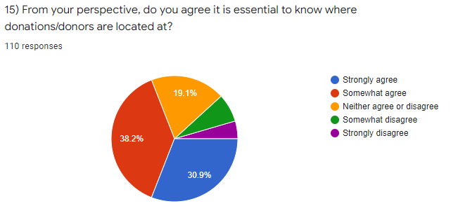

*Figure 3.15*

The results of a survey of respondents' perspectives on the location of the donor or the donation are visualized in Fig 3.15. Based on the result, a total of 38.2 per cent, which represented 42 respondents who are somewhat in agree. Followed by 30.9 per cent, representing a total of 34 respondents who strongly agree. A total of 19.1 per cent, or 21 respondents, indicated that they were neither agreeing nor disagreeing. While a total of 7.3 per cent representing 8 respondents indicated somewhat disagree and lastly a total of 4.5 per cent representing 5 respondents indicated that they strongly disagreed to know the location of donations and donors.

In conclude, based on the results of the data collected, the vast majority of respondents agreed that information about the location of donors and donors was important. This demonstrates that the location of the donor or seeker is one of the factors that must be considered when doing charitable activities.

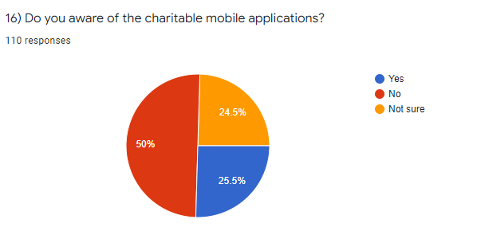

*Figure 3.16*

The results on awareness in charitable mobile application from respondents are visualized in fig 3.16. From the illustrate pie chart, a total of 50 per cent of respondents indicated that they were not aware of the donation application, which amounted to 55 respondents of the total. Furthermore, 25.5 per cent of respondents representing a total of 28 respondents indicated that they are aware of charitable applications, while 24.5 per cent of respondents representing a total of 27 respondents stated that they are not sure to be aware of charitable mobile applications.

In summary, out of 110 respondents, the average number of respondents who are unaware of the donation application is higher than the number of respondents who are aware of the charitable application. This suggests that a significant percentage of the respondents have never utilised their smartphone's charitable application.

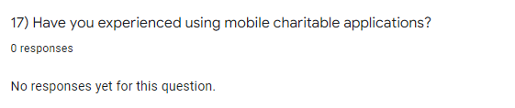

*Figure 3.17*

Figure 3.17 shows the results of a survey of participants on their experiences with charity applications. This question is a types of short answer which need participate to fill up before submit it. The result for this data collected, none of the respondents who responded had previous experience with charity applications. This indicates that the majority of respondents have never used the charity’s mobile application.

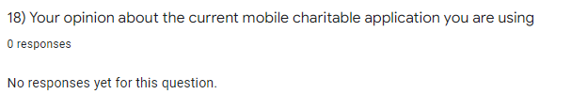

*Figure 3.18*

Figure 3.18 is a short answer question type. The question in this survey to collect of respondents' opinions about their experience using the charitable application existing. Based on the results obtained, no answers were given by the respondents who had experience using the donation application. Therefore, this indicates that most respondents have never used charitable mobile applications on their smartphones.

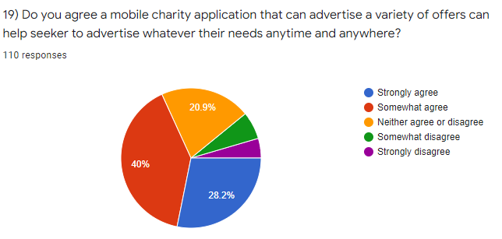

*Figure 3.19*

Figure 3.19 illustrates participants' responses to a survey on whether applications that advertise various types of offers can help them in addressing their needs. The pie chart shows that up to 40 percent of respondents somewhat agreed, which represents 44 respondents. Following with, 28.2 per cent represent 31 of responders indicated that they strongly agree. 20.9 per cent of respondents of 23 people, indicated that they were neither agreeing nor disagreeing. While 6.4 per cent, or 7 respondents, indicated they somewhat disagree, and lastly 4.5 per cent or 5 respondents, stated they strongly disagree.

In summary, out of 110 responders, the average number who agreed was greater than the number who disagreed. This demonstrates that the availability of mobile charity applications able of advertising a variety of different types of offerings will help responders to request help when they are in need.

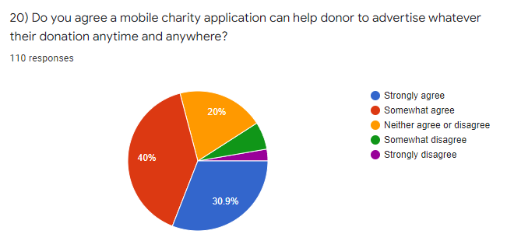

*Figure 3.20*

Figure 3.20 illustrates the results of a survey of respondents who were asked whether a charity application that can advertise any donation will be able to help donors to advertise their donations anywhere they are located. The pie chart shows that up to 40 per cent of respondents somewhat agreed which equals to 44 respondents. Following by 28.2 per cent of responders 31 in total said that they strongly agree. The result of 20.9 per cent represents 23 of the respondents who stated that they were neither agreeing nor disagreeing. While 6.4 per cent or seven respondents claimed they somewhat disagree and 4.5 per cent or five respondents stated they strongly disagree.

In summary, the average number of respondents who agree is greater than the average number of respondents who disagree. This indicates how the availability of mobile charity applications able of advertising any donation allows donors to advertise their donations practically anywhere.

## **3.4 Summarize of the result**

According to the findings of the study, the average male gender respondents who live in the city are more likely to be unemployed than the average female gender respondents. This is significant since the study was conducted throughout the course of a pandemic that was still ongoing at the time of its completion. This was also a contributing factor to many people losing their jobs, which contributed to the high unemployment rate at the period. As a result of the unemployment, many respondents will be seeking for donations, and many people will be donating to the issue. From the perspective of donors, the results show that they are more likely to donate in person than they are to donate through other methods because, the results show that, the trust are issues that they take into account when making donations, leading them to choose to donate in person rather than through other methods. In addition, the result of the survey, while none of the respondents had actually used a charity application on their smartphone, they all agreed that applications that allow people to advertise donations or requests are highly useful to have on hand. As a result, the findings of this study not only have the capacity to help users in their philanthropic causes, but they also indicate that there are still not many applications of this type being developed by other developers. As a result of these findings, the project's significance in supporting the development of a seekandhelp application for smartphones is highlighted.

## **3.5 Improvements**

Following the completion of the systematic review and data questionnaire collection, some of the findings will be applied to the currently proposed Application, SeekandHelp, in order to make improvements to the application. A variety of enhanced features, including such advertising user posts in real time, will be included as well. This enables users to advertise their postings without the need for permission from a third party, which saves energy / cost.

Furthermore, improvements in terms of location are made possible by the use of location-based services powered by Maps, which allow users to locate the whereabouts of other users directly from their phones. In addition, new diversity features and other information have been added, such as categories, searches, user profiles, and feedback, and others. The UI design on SeekandHelp will also be improved in order to make it more user-friendly and easier to understand for people to navigate through.

## **3.6 Functional Requirements**

Functional requirements analysis is an analysis that contains the processes delivered by the information system; the functional requirements analysis carried out at this stage is to see the sorts of functional needs that must be provided in creating a project, particularly in the form of process data that is directly related to the development of this final Project.

Table 2. Functional requirement

|  |  |
| --- | --- |
| 1 | The system is capable of carrying out the user registration process |
| 2 | The system can compute the overall number of registered users. |
| 3 | The system is capable of displaying the information for all registered users. |
| 4 | The system is capable of performing the process of user input. |
| 5 | The system is capable of determining and displaying the quantity of data according to on data categories. |
| 6 | The system is capable of processing data modifications made by users. |
| 7 | The system is capable of locating and displaying the search data that the user has chosen or retrieved. |
| 8 | The system must be capable of displaying both the map's location and the user's position. |
| 9 | The system must be capable of displaying the time associated with each piece of data presented on the post. |
| 10 | The system can carry out the process of searching for data in response to user queries. |
| 11 | The system is capable of locating and displaying the search data that the user has chosen or retrieved. |
| 12 | The system must be capable of displaying links and associating users with the currently selected user. |
| 13 | The system must be capable of displaying the time associated with each piece of data presented on the post. |
| 14 | The system must be capable of displaying both the map's location and the user's position. |

## **3.7 Non-Functional Requirements**

Non-functional system requirements describe the level of quality of the system. Non-functional requirements for example are constraints on services or functions offered by the system such as time constraints, process constraints development and standards. Non-functional requirements are a needs that are not directly related to existing features in the application to be made. On the other hand, non-functional needs limit the functional requirements. For development of this application, the nonfunctional requirements can be found as following;

### 3.7.1 Performance Requirements

1. Performance
2. For the system to run quickly and smoothly, each page on the system will load faster, and all data entered by the user will continue to be published and seen by the system without the need for third-party processing.
3. Scalability
4. The system will continue to improve following the features and functionalities that are tailored to the demands of the users.
5. Usability
6. The proposed system must also perform effectively so that users can understand and use it easily.
7. Compatibility
8. The system is compatible with Android smartphones from version 11 and up to the most recent version.
9. Capacity
10. In order for the system to be efficient, it shall be able to accommodate a large number of users at the same time.
11. Maintainability
12. Maintenance on the server will take place for three hours every week in order to ensure that the system functions smoothly.
13. Security

In order to protect the user's account from unauthorized access, authentication will be utilized when a user has logged into the system. So that only authorized users can access their accounts.

1. Data integrity is important.

In order to ensure accurate data, registered user information will be authenticated in order to ensure that there are no data errors or incorrect formats for each individual user.

### 3.7.2 Hardware Requirements

To design and create the proposed seek and help application, hardware is needed so that the application program created can run properly. The specifications used for the development of this application are as follows:

1. CPU 2.6 Ghz
2. SSD 128GB
3. RAM 16GB
4. Graphics Intel CORE i5
5. Monitor Dell IPS 24
6. Android Device specifications 2GB RAM, OS Version: R, 11
7. Standard devices such as mouse, keyboard etc.

### 3.7.3 Software requirements

In this project, Kodular will be the used to develop the proposed application. The choice of using Kodular Sofware in the development of this application because Kodular is considered to be a fast and very suitable in building small projects [40]. In addition, it also has a large number of support devices available and provides IDE connectivity that can be used on this development project [41].

For the backend, Firebase will be used in this proposed project. According to [42] Firebase is a web application platform that is used for developing web applications. It supports developers in the development of high-quality applications. It saves the data in the JavaScript Object Notation (JSON) format, which does not require the use of queries for the purposes of entering, updating, removing, or adding data to the database. It is the portion of a system's backend that serves as a database for storing information. Moreover, Firebase offers a variety of services such as Firebase Database, Firebase Authentication, Firebase Storage, and etc. The ability to alter and add features to a project is thus made possible [42] [43].

The additional software used to support the making of this application must be in accordance with the needs are as follows

1. Windows 10 pro Operating system
2. Google chrome Web Browser
3. Computer Application
4. Microsoft Visio 2016
5. Microsoft projects 2019
6. Microsoft Word
7. Adobe XD

# **CHAPTER 4**

## **SYNTHESIS**

This chapter will discuss the design of the system design on the application based on the results of the analysis performed in the previous subchapter. The notion of Object Oriented Design will be used in the development of the system on the application [44]. Additionally, in the next subsections, the schematic model and process of the application system will be discussed in terms of the type of diagram in the Unified Model Language (UML) schema, which will be used to illustrate the model and process.

## **4.1 Architectural Design**

The application that will be developed will be based on a client-server architectural system. Users will be able to directly access the server through the utilization of Firebase's APIs as a result of this system architecture. The client section is comprised of an application that has been downloaded and installed on the user's Android mobile device. Users can register on the application and then use the application to begin creating activities.  The client includes all of the activities and features that users perform when using the application. The server part of the application is where all of the data is stored. When a user provides information for the app to store, the information can be received in real time by other users through Firebase's APIs. Figure 4.1 is a design drawing of the component.



*Figure 4.1 architectural design*

## **4.2 Database**

The Firebase database will be used for data storage in this application, which will be integrated with the application by developers. Through the usage of Firebase, all user data may be synced with other users and accessible in real time by others. Because Firebase is based on NoSQL notions, developers no longer have to rely on a related database schema model while working with it. Firebase employs a tree model structure, in which the database will use a unique key value to allow it to be retrieved in real time by the user [45].

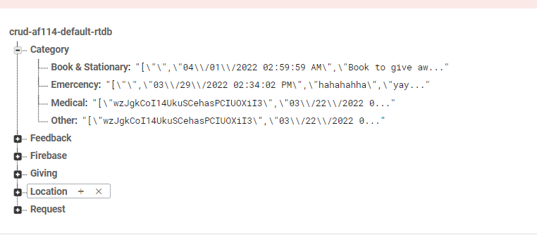

*Figure 4.2 firebase structure*

## **4.3 Process Design**

In this section will be explain the schematic model and working system of the application made. The design of the system in this application will use the concept of object-oriented programming. These processes will be created using UML and explained through the following diagrams

### 4.3.1 UML Use Case

Use case diagram is a diagram to describe the interaction between actors and the system [44]. The activities that can be carried out by users through this application are to seek and share their donation with other users. Showed in Figure 3.1, there are two actors who interact with the application, namely registered users and visitors. Visitors can only register on the application without being able to access other features. Register user is a user who has previously registered and is verified to be able to login to an account on the application. After logging in, talent can search for posts, view post lists and post details, search categories, view detailed posts, provide feedback, view profiles and edit them.



*Figure 4.3 use case diagram*

### 4.3.2 UML Class Diagram

The class diagram of an application seekandhelp is illustrated in the illustration above. There are ten classes, which are as follows: Registration, User, Location, Post, Category, Authentication, Contact, Database, and Feedback. Registration is the first class. Each class has its own set of characteristics. Attributes are needed components for a class to function properly. There is also a list of the needed data types, which include strings, which represent sequences of characters, and integers, which represent numbers. In addition, the operations of classes as well as the relationships between classes and other classes are explicitly defined. One or more registrations for an account are permitted for a user. After completing the account registration process, all of your account information, including your name, username, email address, phone number, and password, will be displayed on the profile page, as shown in the illustration. The user class has various characteristics that correspond to the user profile data, including a name, username, email address, phone number, and password, among others. Login, registration, editing profile, seeing categories, viewing place information, contacting, viewing location, posting, and sending feedback are all examples of user operations that refer to tasks that users can conduct.



*Figure 4.5 Class Diagram*

### 4.3.2 Activity Diagram

Activity diagrams are made to describe the system workflow on the application. The workflow that will be explained is part of the Use case Diagram. Broadly speaking, the existing working system in the application is as follows:



*Figure 4.6 Login activity*

Figure 4.6 is a design activity diagram of the login. Registered users fill out the login form, then press the “Login” button. After that the system will check whether the user is registered in the database, if there is no matching authentication data, a notification will appear that the account has not been registered while if the account is valid the system will be redirected to the main page.



*Figure 4.7 Registration activity*

Register activity for new user involves 4 roles i.e. user, app, Firebase Authentication, Firebase real time databases. The initial stage, show the login page, after the user choose to register, the register page will be show by the system and user will need to fill in the registration details form for registration. When the user finishes entering the information they want to register, firebase authentication will generate a unique key that is only owned by one user. Then the user information and unique key will be saved to the database. After finishing saving data, the application will display a success status and display a login page for the user. Activity flow can be seen in Figure 4.7.



*Figure 4.8 Search activity*

Activities to view and search for posts involve 3 roles which are user, application, and Firebase real-time database. After the user runs the program, the application will ask post information that the user wants on the server to be displayed on the start page. After that the server will send the data obtained and the application will display it on the display page. When the user wants to search for a post, the user can type in the keyword of the item they want to search for, choose a post category or enter a post the information you want to find. After that, the app will sort the data information in accordance with the keywords entered by the user. After the application finds the search result data, the user can see the post data that they are looking for. The activity flow can be seen in Figure 4.8.



* 1. *Create post activity*

The user activity in the activity figure shows to create a new post which involves three roles, namely user, application and Firebase real-time database. An initial activity in this diagram start at fill in the details and information form by user. When the user finishes entering the information the post that they want to published, the system will validate the data before it send and store in database. The firebase database will store the data sent according to the data category and after finishing saving data, the application will display a success status and user can view the posted created. Activity flow can be seen in Figure 4.9



* 1. *Delete post activity*

In this activity, the roles that involved to delete the post will be involves are the user, application, and real-time Firebase databases. In this activity, when the user clicked on deleted button, the system will be show the validation for user to choose, when the validation is meet the next process will be send to the database to execute the request for deleted data. When selected data has been in firebase, the delete success status will be showing the in system and navigate to the main page. The activity flow can be seen in Figure 4.10



* 1. *View post details activity*

In this activity it show the activity for the details post page. The activity of viewing post details are involves 3 roles which are users, apps, Firebase real-time databases. The initial of this activity start when user selected the post to view and the system will request the data related to the post chosen by user to be viewed. The request data received by database and retrieving the requested stored data before it send to the system. After request successful, the system will be show the details data of the post chosen by the user. The activity flow can be seen in Figure 4.11.



Figure 4.12 Feedback activity

Feedback activity is an activity that able user to send their feedback to the developer or admin to be reviewed. The initial of this activity start by the user roles when their fill in the feedback form. After user fill in the feedback, the system will validate it from user before it send the feedback data to the firebase database to be stored. After the data stored in database, the system will show the success send status to inform the user and navigate to the main page. The activity flow can be seen in Figure 4.12.



*Figure 4.13 Contact activity*

Figure 4.13 show contact activity of the user's to connect with other users. This activity of sending barter offers involves 4 roles, namely user, application and Firebase real-time database and Whatapps. The start of this activity starts after the user selects the contact button on the details page. After that, the system will make validation for the user to choose the contact he chooses to connect. After that, the system will send the order to the firebase database to be processed and retrieve the saved contact data and so on, the system display will display navigation to the external page to connect the selected user using WhatsApp. After that on the external page, permission information will be displayed for the user to agree before contacting the selected contact on the system.

* 1. **User Interface Design**

An interface is a component of a system that connecting or bridging between a system and user. With the interface, it will make it easier for users to interact with a system. Following is an overview of the interface on system that has developed.



*Figure 4.14 splash screen*

The splash page is the initial display of the application when it was first launched. This page will display the application logo. This page can be seen in the figure.

|  |  |
| --- | --- |
|  |  |

*Figure 4.15 login page*

After the splash page, the user will be redirected to login view. At the login screen, in this login page will display a form for user to input their email and password. User have to fill in the email and password in the text field correctly, if there is incorrect information the error message will be display regard of the error information. If all the correct information entered, user will be able to login into the application that was created. If user is not have registered, users need to register a new account by clicking the Signup text that linked into register page.

|  |  |
| --- | --- |
|  |  |

*Figure 4.16 registration page*

In the register page, it allow new user to register their information for create a new account of the application. In this register page it will display a form that need new user to fill their information which are their email, username, phone number and their password. User must fill the correct information to be able to register their account. If there is incorrect information entered, the error message will be display to the user to give them what error information for user to correct it back. If all the information has entered correctly, the user will need to click on sign up button to be able send of their data to the system to be verified. After user submit the information, the display of confirmation form will be show to the user which indicate that their application for registration is successful.

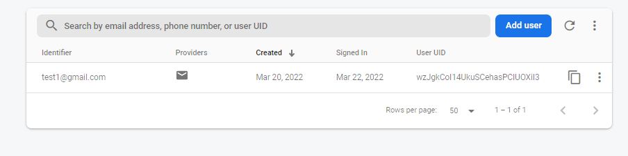

*Figure 4.17 firebase authentication*

Figures 4.17 how the registered information of user has been success stored in database. After the user has submit their registration, the authentication will be create for each user. This authentication will allow user to using this application.

|  |  |  |  |
| --- | --- | --- | --- |
|  |  |  |  |

*Figure 4 .18 navigation menu*

After the user successfully logs in to the application, the application will display the home page where on the display there is a menu that will link to the page that will be selected by the user. The linked pages are categories, creating new posts, menus to profile and home. The menu on this page can be accessed by the user by pressing each selected button

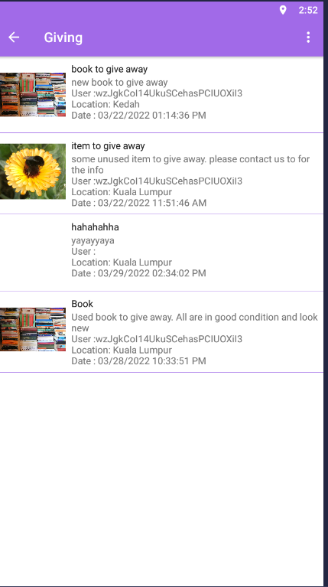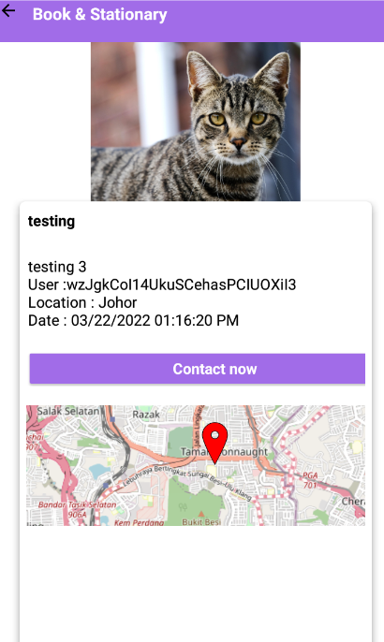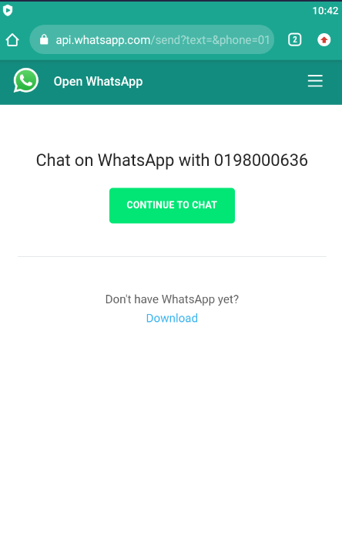

*Figure 4.19 post details page*

Figure 4.19 show the post feed and details interfaces. The detailed information on each selected post can be viewed by such as the title, description about the post, the time it was sent. In addition, there is information from the owner of the post such as their name and location displayed in post details interface. To be able to communicate with the owner of the post, user will need to click on Contact button. The display of the information the number will be show and the the user will be linked on the WhatsApp page permission.

|  |  |
| --- | --- |
|  |  |

*Figure 4.20 create post page*

On this page, the user have will to enter information and details for the desired post into the form displayed. In addition, users will also choose for each type and category that is appropriate for the post created. Users will also choose their location and address before choose the send the post. Before post is send by system, the page will be displayed confirmation to choose by the user.

|  |  |
| --- | --- |
|  |  |

*Figure 4.21 Explore page*

Figure 4.21 show the Explore page, it shows 4 types of post activity to choose. User can click on the all based on their preference to proceed to each pages. Each category has different type of activity. User can click on each category to view all the post for each category. Figure shows the below the some other category such as Medical, clothing, household item, transportation and many more.

|  |  |  |
| --- | --- | --- |
|  |  |  |
|  |  |  |

*Figure 4.22 profile page*

Figure 4.22 show the details of profile page, in this page, user will able to see their information and update their details. User need to input the text field and the button will pop up to able the user save the information. After completed the fill in and choose click save button, the confirmation form will display to ask user for confirmation update.

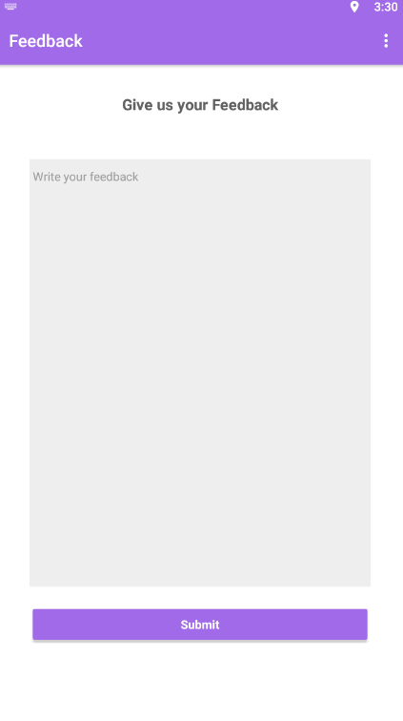

*Figure 4.23*

Figure 4.23 show Feedback interface. In this page, users can post their experiences or problems in feedback on the SeekandHelp app. In this page display the form that can be fill in by user. After the finished filling the form user will need to click the submit button. User post will be send and store to the database for the developer to be read.

# **CHAPTER 5**

## **EVALUATION**

## 

## **5.1 Testing**

After the development of the proposed SeekandHelp charity mobile application is completed, there will be a testing for the proposed application to be conducted as human errors are often occurring during the development of the application. Therefore, application testing is vital to uncover bugs or defects of the application before it is delivered to the client and ensure the application’s quality. It also improves the application's dependability and ease of use. Besides, application that has been thoroughly tested ensures that it is both high-performing and reliable. Moreover, it aids in demonstrating that critical application functions are working in a way that is appropriate for real-world situations and usage. If the application fails to meet user’s expectation, it will be documented and sent back to the developers for repair. This testing phase acts as a final checking to ensure that the final version of proposed application is well-constructed.

## **5.2 User Acceptance Test**

User Acceptance Test (UAT) will be carried out for testing of the proposed application. It helps to make sure that the overall acceptance rate of the new proposed application. A total of 5 users will be invited to participate in the user acceptance test. UAT form will be given to each of the participant. Users are required to complete the form based on own experience after tested and used the proposed application. The UAT form is divided into 5 part which included overall performance, categories and information of places, google maps, travel forum as well as news and information.

UAT Form of Participant 1

|  |  |  |  |  |  |
| --- | --- | --- | --- | --- | --- |
| User Acceptance Testing Form | | | | | |
| Name of Tester: Ashwini A/P Krisnavalue | | | | | |
| No | Description | Menu Function | Pass | Fail | Comment |
| Application Menu Testing | | | | | |
| 1 | Register | Used to register a new user to gain access to the system |  |  | No comment |
| 2 | Login | Used to gain access to enter into the system |  |  | No comment |
| 3 | Forgot password | To send the link for user to reset the forgot password |  |  | No email detected |
| 4 | Create post | To give user fill in the details of form to be shared |  |  | No comment |
| 5 | Post details | The view the details of each post selected |  |  | No comment |
| 6 | Delete the post | Delete the selected post |  |  | No comment |
| 7 | Search | Used to search and display the input data requested |  |  | No comment |
| 8 | Send Feedback | Used to fill in form to be send to developer/admin |  |  | No comment |
| 9 | Navigation | Used to linked each of navigation to another page |  |  | No comment |
| 10 | Edit user profile | Allow user to change the profile details |  |  | The edit is not working |
| 11 | Category | Collection of each listed post in the app |  |  | Some category is not listed |
| 12 | Contact | Link into the user contact information |  |  | No comment |
| 13 | Google Map | Show the location of user |  |  | Map not showing |
| Application Overall Performance testing | | | | | |
| 14 | User Interface | The layout and design to be view end user |  |  | User interface can be improve |
| 15 | User friendly | To make user easy and understanding to use |  |  | No comment |
| 16 | Loading time | The loading time takes from page to another page |  |  | No comment |

UAT Form of Participant 2

|  |  |  |  |  |  |
| --- | --- | --- | --- | --- | --- |
| User Acceptance Testing Form | | | | | |
| Name of Tester: Duncan Danesh A/L Antau | | | | | |
| No | Description | Menu Function | Pass | Fail | Comment |
| Application Menu Testing | | | | | |
| 1 | Register | Used to register a new user to gain access to the system |  |  | No comment |
| 2 | Login | Used to gain access to enter into the system |  |  | No comment |
| 3 | Forgot password | To send the link for user to reset the forgot password |  |  | Not received the link to email for reset the password |
| 4 | Create post | To give user fill in the details of form to be shared |  |  | No comment |
| 5 | Post details | The view the details of each post selected |  |  | No comment |
| 6 | Delete the post | Delete the selected post |  |  | Some post is not delete choose to delete |
| 7 | Search | Used to search and display the input data requested |  |  | No comment |
| 8 | Send Feedback | Used to fill in form to be send to developer/admin |  |  | No comment |
| 9 | Navigation | Used to linked each of navigation to another page |  |  | No comment |
| 10 | Edit user profile | Allow user to change the profile details |  |  | The profile can be view but can’t edit |
| 11 | Category | Collection of each listed post in the app |  |  | No comment |
| 12 | Contact | Link into the user contact information |  |  | No comment |
| 13 | Google Map | Show the location of user |  |  | Unusual behavior, sometime map is showing and not |
| Application Overall Performance testing | | | | | |
| 14 | User Interface | The layout and design to be view end user |  |  | No comment |
| 15 | User friendly | To make user easy and understanding to use |  |  | No comment |
| 16 | Loading time | The loading time takes from page to another page |  |  | No comment |

UAT Form of Participant 3

|  |  |  |  |  |  |
| --- | --- | --- | --- | --- | --- |
| User Acceptance Testing Form | | | | | |
| Name of Tester: Justin Lim Chia Jun | | | | | |
| No | Description | Menu Function | Pass | Fail | Comment |
| Application Menu Testing | | | | | |
| 1 | Register | Used to register a new user to gain access to the system |  |  | No comment |
| 2 | Login | Used to gain access to enter into the system |  |  | No comment |
| 3 | Forgot password | To send the link for user to reset the forgot password |  |  | No email received |
| 4 | Create post | To give user fill in the details of form to be shared |  |  | No comment |
| 5 | Post details | The view the details of each post selected |  |  | No comment |
| 6 | Delete the post | Delete the selected post |  |  | No comment |
| 7 | Search | Used to search and display the input data requested |  |  | No comment |
| 8 | Send Feedback | Used to fill in form to be send to developer/admin |  |  | No comment |
| 9 | Navigation | Used to linked each of navigation to another page |  |  | No comment |
| 10 | Edit user profile | Allow user to change the profile details |  |  | I can’t edit the profile |
| 11 | Category | Collection of each listed post in the app |  |  | No comment |
| 12 | Contact | Link into the user contact information |  |  | No comment |
| 13 | Map | Show the location of user |  |  | Not showing the location |
| Application Overall Performance testing | | | | | |
| 14 | User Interface | The layout and design to be view end user |  |  | Pass but I think need more improvement |
| 15 | User friendly | To make user easy and understanding to use |  |  | No comment |
| 16 | Loading time | The loading time takes from page to another page |  |  | No comment |

UAT Form of Participant 4

|  |  |  |  |  |  |
| --- | --- | --- | --- | --- | --- |
| User Acceptance Testing Form | | | | | |
| Name of Tester: Lee Wei Hong | | | | | |
| No | Description | Menu Function | Pass | Fail | Comment |
| Application Menu Testing | | | | | |
| 1 | Register | Used to register a new user to gain access to the system |  |  | No comment |
| 2 | Login | Used to gain access to enter into the system |  |  | No comment |
| 3 | Forgot password | To send the link for user to reset the forgot password |  |  | No comment |
| 4 | Create post | To give user fill in the details of form to be shared |  |  | No comment |
| 5 | Post details | The view the details of each post selected |  |  | No comment |
| 6 | Delete the post | Delete the selected post |  |  | Not woking |
| 7 | Search | Used to search and display the input data requested |  |  | Not working |
| 8 | Send Feedback | Used to fill in form to be send to developer/admin |  |  | No comment |
| 9 | Navigation | Used to linked each of navigation to another page |  |  | No comment |
| 10 | Edit user profile | Allow user to change the profile details |  |  | I can’t edit my profile |
| 11 | Category | Collection of each listed post in the app |  |  | Category can be improve and add more list |
| 12 | Contact | Link into the user contact information |  |  | No comment |
| 13 | Google Map | Show the location of user |  |  | Map not showing location |
| Application Overall Performance testing | | | | | |
| 14 | User Interface | The layout and design to be view end user |  |  | No comment |
| 15 | User friendly | To make user easy and understanding to use |  |  | Can improve more |
| 16 | Loading time | The loading time takes from page to another page |  |  | No comment |

UAT Form of Participant 5

|  |  |  |  |  |  |
| --- | --- | --- | --- | --- | --- |
| User Acceptance Testing Form | | | | | |
| Name of Tester: Au Fun Lee | | | | | |
| No | Description | Menu Function | Pass | Fail | Comment |
| Application Menu Testing | | | | | |
| 1 | Register | Used to register a new user to gain access to the system |  |  | No comment |
| 2 | Login | Used to gain access to enter into the system |  |  | No comment |
| 3 | Forgot password | To send the link for user to reset the forgot password |  |  | No comment |
| 4 | Create post | To give user fill in the details of form to be shared |  |  | No comment |
| 5 | Post details | The view the details of each post selected |  |  | No comment |
| 6 | Delete the post | Delete the selected post |  |  | No comment |
| 7 | Search | Used to search and display the input data requested |  |  | No comment |
| 8 | Send Feedback | Used to fill in form to be send to developer/admin |  |  | No comment |
| 9 | Navigation | Used to linked each of navigation to another page |  |  | No comment |
| 10 | Edit user profile | Allow user to change the profile details |  |  | Not able to change the profile |
| 11 | Category | Collection of each listed post in the app |  |  | No comment |
| 12 | Contact | Link into the user contact information |  |  | No comment |
| 13 | Google Map | Show the location of user |  |  | Not showing location |
| Application Overall Performance testing | | | | | |
| 14 | User Interface | The layout and design to be view end user |  |  | Average |
| 15 | User friendly | To make user easy and understanding to use |  |  | No comment |
| 16 | Loading time | The loading time takes from page to another page |  |  | No comment |

## **5.3 Discussion on the UAT Results**

According to the UAT form collected from the participants, both participants have a positive experience of using the proposed application. They are satisfied with the proposed application as it met the user’s expectation. Each of the feature is functioning well and the overall application is easy to use. For conclude, the develop application had successfully improved to meet and satisfy user’s overall experience. However, there are several comments from the participants such as some of the function in the application is slightly not working. Besides, the lack of user interface, it can be approve to give more live and interest for user to use. Search function, edit profile, delete post are the need to be improved. Furthermore, Google Maps feature in the proposed application can be improved to make it work properly and add more function for showing of nearby location of users located in Google Map. Moreover, the profile edit page, forgot password issues need to be fixed.

# **CHAPTER 6**

## **CONCLUSIONS AND RECOMMENDATIONS**

## 6.1 Conclusion

In conclusion, the objectives of the research project are clearly outlined in the methodological procedure, which is used to carry out the whole process to resolve the issues found in the existing application. The aim of this project is to develop a user-friendly, simple and efficient charity app that runs on a mobile platform to help all users advertising for help or donation according to their need. Systematic reviews and studies of existing applications and systems and questionnaire have been conducted to determine the existing issues and analysis. The charity SeekandHelp app is designed and implemented to meet all objectives and improve all existing problems. The proposed application has been implemented using the Kodular builder Platform and is compatible with Android-based mobile devices. Although it is not perfect, it has managed to meet all the objectives and improve the user experience based on the feedback from the participants who participated in the user acceptance test. The proposed applications can be further developed and enhanced in the future.

## 6.2 Limits

The proposed application is not in perfect condition due to some limitations of this project. The main limitation forto this project is the constraint of the developer such as lack of programming knowledge to implement the proposed application. In addition, the limited time is another constraint for this project. Better output for the proposed application can be produced if there is more time available. Developers have limited time to do research and learn the knowledge and skills needed to develop a proposed application. It causes developers to face some problems while implementing all the features in the proposed application. In addition, the problem is the change of development tools also becomes one of the limitations where each tool has a different use causing changes to the planned system. Therefore, understanding in decision making in the selection of appropriate tools to be used in application development is one of the limitations in the development of this project.

According to the feedback from the user acceptance test, there were some limitations stated by the participants. Some pages in the proposed app are a bit left out. In addition, fewer venue categories are provided in the proposed activity post. In addition, Maps does not work well for users to view donations or search for donations around nearby places. In addition, the forget password feature does not work fully.

## 6.3 Recommendations

All recommendations and feedback from users will be taken into account for future improvements and enhancements to the proposed application. The proposed application is an android based application, it can be improved to support other platforms such as IOS, windows and so on. It will result in an increase in the number of different users using the proposed application. Additionally, the adaptability of the app to the resolution and screen size of the device can be enhanced to make it more dynamic. The proposed application will be more attractive and able to attract the attention of potential users by being built to be compatible with various screen sizes and resolutions.

Furthermore, more post categories can be added to the proposed app to provide more options for users. The development of the system that can be done in the next research is to add payment gateway features to facilitate donors in donating funds and shorten the time, for maximum results that can run on all mobile platforms. Moreover, We will make every effort to obtain further responses in the future, despite the small number of people that took part in the survey. The new form will enable the processing of a greater number of metrics. New questions will be added after an analysis of the available data is completed.

# References

[1] A. Kumar and S. Chakrabarti, “Charity Donor Behavior: A Systematic Literature Review and Research Agenda,” *J. Nonprofit Public Sect. Mark.*, vol. 00, no. 00, pp. 1–46, 2021, doi: 10.1080/10495142.2021.1905134.

[2] S. N. Saleh, C. U. Lehmann, and R. J. Medford, “Early crowdfunding response to the COVID-19 pandemic: Cross-sectional study,” *J. Med. Internet Res.*, vol. 23, no. 2, pp. 1–12, 2021, doi: 10.2196/25429.

[3] S. Gordon, “Internet 101,” *Comput. Secur.*, vol. 14, no. 7, pp. 599–604, 1995, doi: 10.1016/0167-4048(96)81666-X.

[4] B. M. Leiner *et al.*, “A brief history of the internet,” *ACM SIGCOMM Comput. Commun. Rev.*, vol. 39, no. 5, pp. 22–31, 2009, doi: 10.1145/1629607.1629613.

[5] Department of Statistics Malaysia, “Department of Statistics Press Release Ict Use and Access By Individuals and Households Survey Report ,” *29 July 2016*, no. July, pp. 1–3, 2016, [Online]. Available: https://www.statistics.gov.my/index.php?r=column/cthemeByCat&cat=395&bul_id=Q3l3WXJFbG1PNjRwcHZQTVlSR1UrQT09&menu_id=amVoWU54UTl0a21NWmdhMjFMMWcyZz09.

[6] S. Rappaport, P. Podsiadlowski, and I. Horev, “The past and future history of Regulus,” *Astrophys. J.*, vol. 698, no. 1, pp. 666–675, 2009, doi: 10.1088/0004-637X/698/1/666.

[7] Statcounter Global Stats, “Mobile Operating System Market Share Malaysia,” 2021. https://gs.statcounter.com/os-market-share/mobile/malaysia. (accessed Oct. 15, 2021).

[8] D. Felker, *Android Application Development for For Dummies*. 2011.

[9] R. Talha, “Kajian Kes Impak Perintah Kawalan Pergerakan Kepada Penduduk Malaysia,” *Dep. Stat. Malaysia*, no. 17, pp. 1–3, 2020, [Online]. Available: https://www.dosm.gov.my/v1/uploads/files/6_Newsletter/Newsletter 2020/DOSM_BPPD_1-2020_Siri-17.pdf.

[10] S. A. Bin-Nashwan and M. Al-Daihani, “Fundraising campaigns via social media platforms for mitigating the impacts of the COVID-19 epidemic,” *J. Islam. Mark.*, vol. 12, no. 3, pp. 576–597, 2020, doi: 10.1108/JIMA-07-2020-0200.

[11] Y. Li and L. Yu, “Factors influencing social media users’ continued intent to donate,” *Sustain.*, vol. 12, no. 3, 2020, doi: 10.3390/su12030879.

[12] S. Sura, J. Ahn, and O. Lee, “Factors influencing intention to donate via social network site (SNS): From Asian’s perspective,” *Telemat. Informatics*, vol. 34, no. 1, pp. 164–176, 2017, doi: 10.1016/j.tele.2016.04.007.

[13] Y. Chen, R. Dai, J. Yao, and Y. Li, “Donate time or money? The determinants of donation intention in online crowdfunding,” *Sustain.*, vol. 11, no. 16, 2019, doi: 10.3390/su11164269.

[14] Lely Priska D. Tampubolon, “Contribution of the Social Media and Transparency Needed on Crowd funding Website,” *Int. J. Progress. Sci. Technol.*, vol. 9, no. 1, pp. 91–100, 2018.

[15] A. Tomczak and A. Brem, “A conceptualized investment model of crowdfunding,” *Ventur. Cap.*, vol. 15, no. 4, pp. 335–359, 2013, doi: 10.1080/13691066.2013.847614.

[16] J. Hemer, “A snapshot on crowdfunding,” *Enconstor*, p. 39, 2011.

[17] W. K. Bryant, H. Jeon-Slaughter, H. Kang, and A. Tax, “Hyojin Kang and Aaron Tax Participation in Philanthropic Activities : Donating Money and Time,” *J. Consum. Policy*, vol. 26, pp. 43–73, 2003.

[18] T. Nowski, M. O’Flanagan, and L. Taliento, “A Transformative Moment For Philanthropy,” *McKinsey Co.*, no. May, 2020, [Online]. Available: https://www.mckinsey.com/industries/public-and-social-sector/our-insights/a-transformative-moment-for-philanthropy#.

[19] A. Elengoe, “Osong Public Health and Research Perspectives COVID-19 Outbreak in Malaysia,” *Osong Public Heal. Res. Perspect. J.*, vol. 11, no. 3, pp. 93–100, 2020, [Online]. Available: https://doi.org/10.24171/j.phrp.2020.11.3.08.

[20] R. U. Ayres, “The Internet and the World Wide Web,” *Hist. Futur. Technol.*, pp. 519–557, 2021.

[21] N. Heslop, “CAF World Giving Index 2021,” no. June, pp. 1–42, 2021.

[22] H. M. Aji *et al.*, “Investigating the determinants of online infaq intention during the COVID-19 pandemic: an insight from Indonesia,” *J. Islam. Account. Bus. Res.*, vol. 12, no. 1, pp. 1–20, 2021, doi: 10.1108/JIABR-05-2020-0136.

[23] A. H. B. M. Noor, N. A. M. Isa, H. M. Irpan, H. Bin Bahrom, A. B. M. Salleh, and A. R. Bin Ridzuan, “Characteristic Affecting Charitable Donations Behavior: Empirical Evidence from Malaysia,” *Procedia Econ. Financ.*, vol. 31, no. January 2016, pp. 563–572, 2015, doi: 10.1016/s2212-5671(15)01202-2.

[24] F. Almeida, J. Duarte Santos, and J. Augusto Monteiro, “The Challenges and Opportunities in the Digitalization of Companies in a Post-COVID-19 World,” *IEEE Eng. Manag. Rev.*, vol. 48, no. 3, pp. 97–103, 2020, doi: 10.1109/EMR.2020.3013206.

[25] Jom donate, “JomDonate,” 2021. https://www.jomdonate.com/ (accessed Oct. 14, 2021).

[26] share the meal, “Share The Meal,” 2021. https://sharethemeal.org/ (accessed Oct. 14, 2021).

[27] simply giving, “Simply Giving,” 2021. https://www.simplygiving.com/ (accessed Oct. 14, 2021).

[28] Great heart charity, “great Heart Charity,” 2021. https://www.greatheartcharity.org.my/ (accessed Oct. 14, 2021).

[29] A. Phongtraychack and D. Dolgaya, “Evolution of Mobile Applications,” *MATEC Web Conf.*, vol. 155, pp. 1–7, 2018, doi: 10.1051/matecconf/201815501027.

[30] O. Korableva, T. Durand, O. Kalimullina, and I. Stepanova, “Usability testing of MOOC: Identifying user interface problems,” *ICEIS 2019 - Proc. 21st Int. Conf. Enterp. Inf. Syst.*, vol. 2, no. Iceis, pp. 468–475, 2019, doi: 10.5220/0007800004680475.

[31] W. M. Hwu, “CUDA application development,” *2008 IEEE Hot Chips 20 Symp. HCS 2008*, no. November, pp. 44–50, 2016, doi: 10.1109/HOTCHIPS.2008.7476522.

[32] E. W. M. Nivea Coelho Degasperi, “What motivates money donation? A study on external motivators,” *Rev. Adm.*, pp. 363–373, 2017.

[33] T. Widiyaningtyas, D. D. Prasetya, and A. P. Wibawa, “Adaptive Campus Virtual Tour using Location-Based Services,” *2018 Electr. Power, Electron. Commun. Control. Informatics Semin. EECCIS 2018*, pp. 419–423, 2018, doi: 10.1109/EECCIS.2018.8692853.

[34] C. S. Mon, K. Y. Cheng, A. S. Shibghatullah, and C. S. Mon, “Mobile application: donate day,” *J. Phys. Conf. Ser.*, vol. 1529, no. 3, 2020, doi: 10.1088/1742-6596/1529/3/032022.

[35] S. Belekar, R. Rajput, and K. Gharat, “MOBILE APPLICATION FOR DONATION OF ITEMS,” vol. 1, no. 4, pp. 1–6, 2021.

[36] C. N. Olipas, C. N. P. Olipas, and E. M. Villanueva, “Dug-Uhay : A Blood Donor Finder Application Dug-Uhay : A Blood Donor Finder Application,” 2019.

[37] M. Nayak and K. A. Narayan, “Strengths and Weakness of Online Surveys,” *IOSR J. Humanit. Soc. Sci.*, vol. 24, no. 5, pp. 31–38, 2019, doi: 10.9790/0837-2405053138.

[38] S. Dwivedi, “Software Development Life Cycle Models - A Comparative analysis,” *Ijarcce*, vol. 5, no. 2, pp. 232–233, 2016, doi: 10.17148/IJARCCE.2016.5246.

[39] M. K. J. AL Mukhaini and K. Al Harthy, “Propose an advanced smart system of vehicle accidents detection,” *J. Student Res.*, pp. 1–9, 2020, doi: 10.47611/jsr.vi.890.

[40] E. Mavropoulou, “PLATFORMS FOR MOBILE APPLICATION DEVELOPMENT FOR EDUCATIONAL PURPOSES,” 2021.

[41] M. R. Syarlisjiswan, Sukarmin, and D. Wahyuningsih, “The development of e-modules using Kodular software with problem-based learning models in momentum and impulse material,” *IOP Conf. Ser. Earth Environ. Sci.*, vol. 1796, no. 1, 2021, doi: 10.1088/1742-6596/1796/1/012078.

[42] S. Sarkar, S. Gayen, and S. Bilgaiyan, “Android Based Home Security Systems Using Internet of Things(IoT) and Firebase,” *Proc. Int. Conf. Inven. Res. Comput. Appl. ICIRCA 2018*, no. Icirca, pp. 102–105, 2018, doi: 10.1109/ICIRCA.2018.8597197.

[43] Firebase, “Firebase Realtime Database,” 2021. https://firebase.google.com/docs/database.

[44] Z. A. K. Hamza and M. Hammad, “Testing approaches for Web and mobile applications: An overview,” *Int. J. Comput. Digit. Syst.*, vol. 90, no. 4, pp. 657–664, 2020, doi: 10.12785/ijcds/090413.

[45] C. Khawas and P. Shah, “Application of Firebase in Android App Development-A Study,” *Int. J. Comput. Appl.*, vol. 179, no. 46, pp. 49–53, 2018, doi: 10.5120/ijca2018917200.

**APPENDIX**

Survey form

<https://docs.google.com/forms/d/1HjN9Im044qfWz9zxmHnn_xOFoU0VPhzBl3ZdkpeCtys/edit>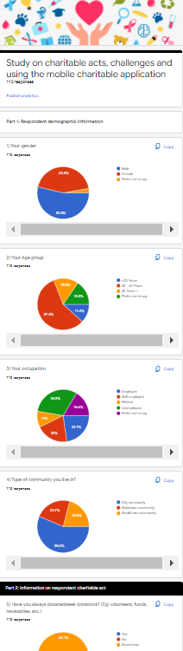

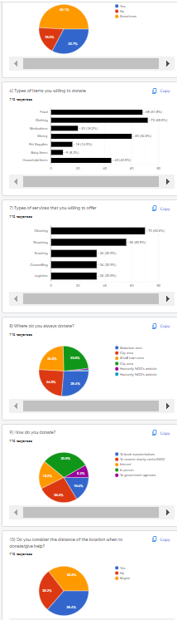

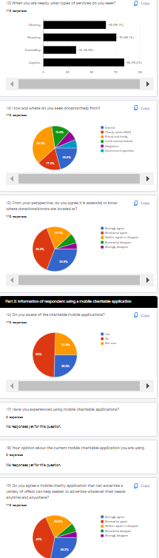

1.